**The Paston Heritage Blofield Walk**

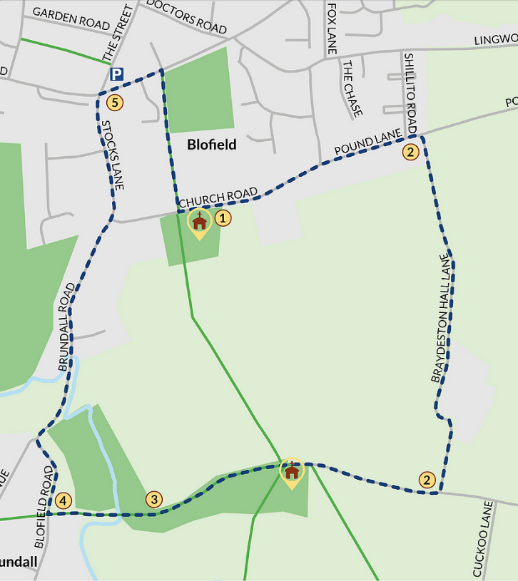**Explore the church and healing herb garden.**

**Braydeston Hall site**

Keeping the church on your right-hand side, follow Church Road Right into Braydeston Lane and follow the road until you reach a group of buildings on the left-hand side.

**Turn right at the T-junction towards Braydeston Church St Michael and All Angels church.** The church was supported by the Berney family and Osbert Berney’s brass memorial, who died as a result of the Siege of Caister rests here. Edward Paston’s marriage to Margaret Berney in 1588 brought Edward many estates which included Str and Reedham.

**Follow the footpath through the gates and along the meadow until you reach Blofield Road.** Please note that there is sometimes cattle and a bull grazing in this field. For an alternative route follow the footpath by Braydeston church back to Blofield church.

**Turn right and follow Blofield Road.** Keep right until you reach Yarmouth Road.

**At Yarmouth Road, turn right and then right again down the footpath**

Walk along the playing field back towards the church where you began.

For more details about Blofield’s links with the Pastons, to leave an anonymous review of the walk or engage in creative activities or reading after the walk, & for more Paston walks in Norfolk, visit: pastonfootprints.co.uk